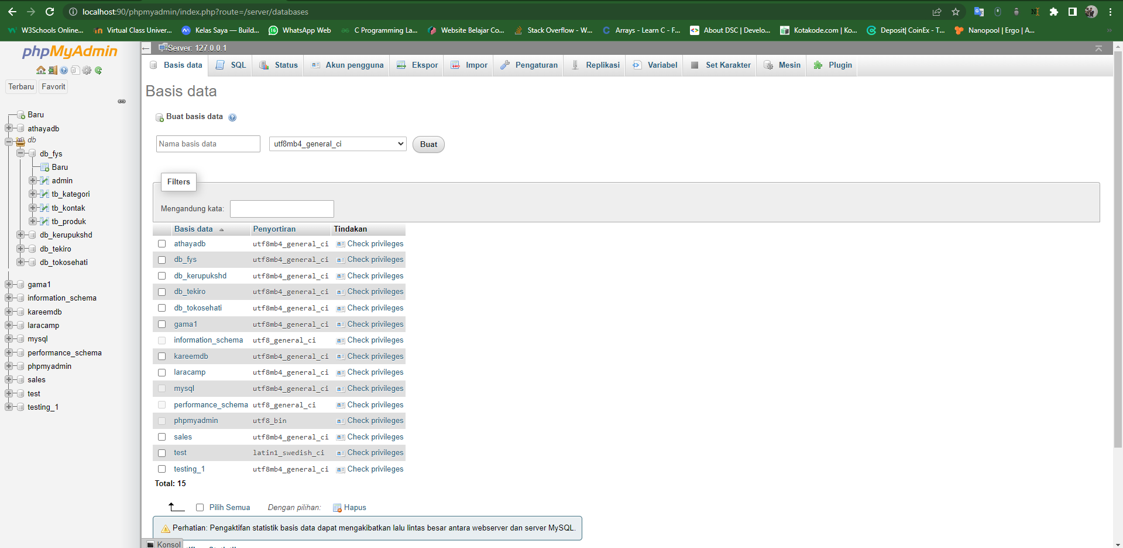

Lu ke localhost/phpMyAdmin/

Trus ke basis data

Buat database baru Namanya db_fys

klo udah ke impor

Baru pencet yang choose file

Masukin database yg lu download

Klo udah… file yg foldernya copy kedalem folder C:\xampp\htdocs